Weekly Monitoring Log for Monday, 9/26/16 - Friday, 9/30/16
Current Learning Goal: TSW understand how the Earth’s natural processes have shaped its landscape (including Lithospheric Plates and their movement, Convergent, Divergent, and Transform boundary landforms). | 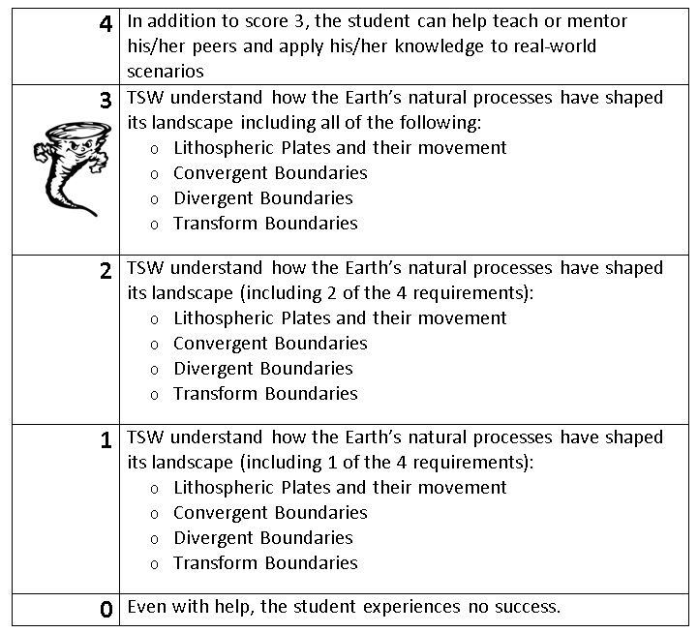
MONDAY:
Response to Warm-Up Prompt: | Today I learned that…
Learning Scale/Rubric Self-Assessment and Justification: | Comments from Mr. Pysher for today:
TUESDAY:
Response to Warm-Up Prompt: | Today I learned that…
Learning Scale/Rubric Self-Assessment and Justification: | Comments from Mr. Pysher for today:
WEDNESDAY:
Response to Warm-Up Prompt: | Today I learned that…
Learning Scale/Rubric Self-Assessment and Justification: | Comments from Mr. Pysher for today:

THURSDAY:
Response to Warm-Up Prompt: | Today I learned that…
Learning Scale/Rubric Self-Assessment and Justification: | Comments from Mr. Pysher for today:

FRIDAY:
Response to Warm-Up Prompt: | Today I learned that…
Learning Scale/Rubric Self-Assessment and Justification: | Comments from Mr. Pysher for today:

Current Science LETTER Grade:___________

Summary of what I learned in science this week:

Other information I want Mr. Pysher to know about my participation/involvement in class this week:

Student Signature:____________________________________ Date:________________

Parent Signature:_____________________________________ Date:________________

